

**REGIONAL REPRESENTATION FOR AFRICA STRATEGY 2020-2023**

***Draft - July 2020***

1. **INTRODUCTION *– Promoting change for increased impact in Africa***

Profound changes are taking place in Africa, including rapid urbanisation, which can represent opportunities for economic transformation and reduction of inequalities. At the same time, there are increased challenges facing cities such as planning, climate change, migration and internally displaced persons, as well as the demographic pressure especially in secondary cities. Additionally, the emergency of pandemics such as COVID-19 indicates the need for a new business model for planning African cities, especially in the context of rural-urban migration. The continent’s increased urban population is a powerful asset for its overall transformation and can attain its full potential once cities are properly planned and adequately serviced. However, it is essential to be cognizant of the fact that advancing the urban agenda in Africa will depend on each country’s specific context and prevailing situations.

This strategy of the Regional Representation for Africa (RRA) is in line with the UN-Habitat Strategic Plan 2020-2023, which reinforces UN-Habitat’s role as the global centre of excellence on sustainable urban development, offering solutions that help seize the opportunities presented by urbanization, while bringing about transformational change for the benefit of millions of people, ensuring that no one and no place is left behind. Through its normative and operational work, the Agency’s objective is to *“advance sustainable urbanization as a driver of development and peace to improve living conditions for all*”. In turn, the RRA Strategy is meant to adapt the UN-Habitat Strategic Plan’s objective, domains of change and desired outcomes to the sub-Saharan African context. The RRA Strategy is also informed by the internal UN-Habitat restructuring process, thus advocating for a new regional architecture to better serve the region. It takes into consideration the UN-Habitat COVID-19 Response and Recovery Strategy for Sub-Saharan Africa, which focuses on slums and informal settlements and pretends to build partnerships other United Nations Agencies at the country level, providing UN-Habitat’s added-value to on-going initiatives.

UN-Habitat’s RRA is working with African governments and regional institutions to take early action to position themselves for responding to the needs of urban populations. The current active portfolio of projects is spread across twenty-four (24) countries. This RRA Strategy marks a paradigm shift towards sustainable urbanisation as an engine for growth by proactively tackling urban challenges while simultaneously leveraging the opportunities presented by the phenomenon itself. It also repositions the RRA in effectively contributing to embedding the urban agenda into the broader African development vision articulated in Agenda 2063: a prosperous and peaceful Africa, driven by its own citizens, representing a dynamic force in the international arena.

1. **BACKGROUND *– African cities today and tomorrow***

Africa is undergoing rapid urbanisation that will result in almost 1.33 billion people living in cities by 2050, compared to 470 million at present. Around 2030, Africa’s collective population will become 50 percent urban. The majority of political constituencies will then live in cities, demanding means of subsistence, shelter and services. African governments should position themselves to be ready for predominantly urban populations. Since cities are the future habitat for the majority of Africans, now is the time for investing in basic infrastructure, social services (health and education) and affordable housing, thereby stimulating urban economies and generating much-needed jobs. Not a single African government can afford to ignore the on-going rapid urban transition. Cities must become priority areas for public policies, with investment provided to build adequate governance capacities, equitable service delivery, affordable housing provision and better wealth distribution.

Additionally, financing urbanisation through land value capture is quite obvious today, given the size of the required investments and constraint weighing on the traditional financing of development. Also bearing in mind that existing urban risks and vulnerabilities in the region are exacerbated by the increasing severity and unpredictability of climate change effects, including COVID-19. The latter was declared a pandemic by World Health Organization (WHO) in early 2020, and is having negative economic impact in many countries across the world. Building urban resilience in African cities has never been more crucial.

1. **GUIDING INSTRUMENTS – *Our starting point is the region itself***

One of the aspirations of the African Union is “*a prosperous Africa based on inclusive growth and sustainable* *development*”. This ambition is meant to be translated into a high standard of living and quality of life and well-being for the African people; well educated citizens and a skills revolution underpinned by science, technology and innovation; citizens who are healthy, well-nourished and have long life spans; cities, peri-urban and rural communities that are equipped with modern communication, transport, sanitation, education and health facilities, as well as people who have access to affordable and decent housing. The adoption of Agenda 2063 further reaffirmed not only the strong commitment of the continent’s Heads of State and Government to structural transformation but also explicitly underlined the need for harnessing the potential of urbanisation in the continent’s development. This is crystalized in the Harmonized Regional Framework for the Implementation of the New Urban Agenda in Africa, which is guided by Agenda 2063 and is based on 6 transformative policy outcomes and the Common African Position towards Habitat III.

**FRAMEWORK OF INTERVENTION AND GUIDING INSTRUMENTS**

* SDGs 2030 with a focus on SDG 11: Sustainable Cities and Communities
* New Urban Agenda 2016-2036
* Africa Agenda 2063
* UN-Habitat Strategic Plan 2020-2023



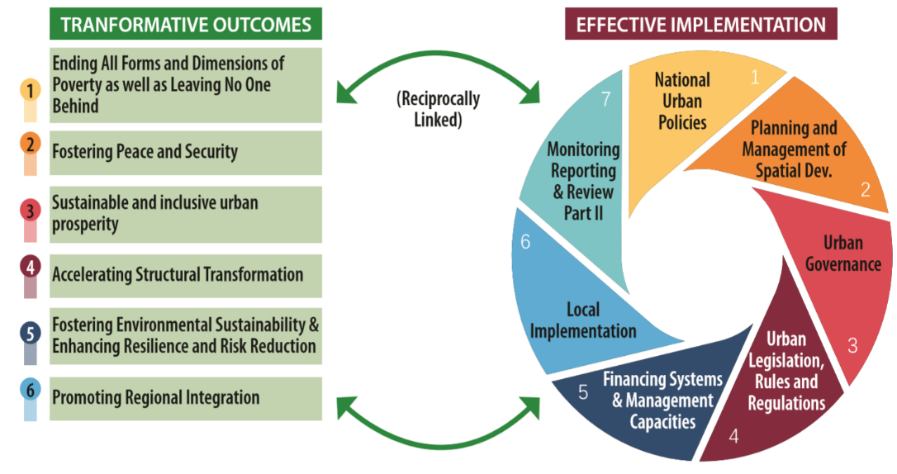

1. **CURRENT PORTFOLIO – *What we build on***

The Regional Representation for Africa covers Sub-Saharan Africa, which consists of 49 countries out of which 24 are considered to be active portfolios (i.e. with staffing on the ground and on-going projects). Country and regional projects and programmes utilise innovative UN-Habitat tools and approaches and focus on, mainly: **Basic Services & Infrastructure** Development;Durable Solutions for Internally Displaced People and Refugees; Enhanced Urban Governance; Promotion of **Peace and Stability through Participatory Planning Approaches, Conflict Resolution and Social Cohesion; Urban** Resilience, Risk Reduction and Climate Change Adaptation; Urban and Regional Planning; and Youth Empowerment and Livelihoods. Lessons learnt from 2014-2019 interventions were instrumental to develop the 2020-2023 RRA Strategy, which is anchored in a Theory of Change that contributes towards achieving the objectives of structural transformation in Africa.

WHERE WE ARE IN AFRICA TODAY

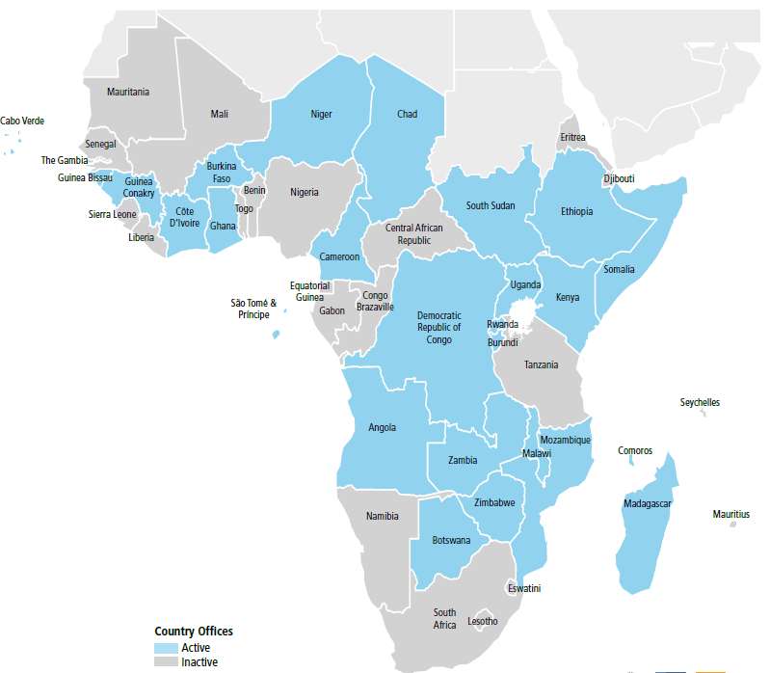

**THEORY OF CHANGE**

**Transformative, Resilient**

**and Peaceful Cities**

Build Resilient Cities

(Enhanced Social Integration and Climate Adaptation)

Reduce Social Inequalities

(Basic Services, Affordable Housing and Urban Regeneration)

Attract investments (Connectivity, Production & Innovation)

**Prevention**

* Informal settlements
* Disease spread
* Climate disaster
* Migration
* Conflict

Secondary Cities

Strengthen Good Governance and National Urban Policies

NUP & Governance

Build Resilience and Promote Social Integration, Peace & Security

Deliver Affordable Housing, Basic Services and Infrastructure

Promote Urban Planning & Unlock Local Finance

Strengthened Climate Action & Improved Urban Environment

Enhanced Shared Prosperity of Cities and Regions

Reduced Spatial & Poverty inequalities in Communities across the Urban-Rural Continuum

Effective Urban Crisis Prevention & Response

1. **OVERALL GOAL *– Our aspiration for the region***

|  |
| --- |
| **TO LEVERAGE SUSTAINABLE URBANISATION**  **FOR TRANSFORMATIVE, RESILIENT AND PEACEFUL CITIES IN AFRICA** |

A key premise of the RRA Strategy is to ensure the full realisation of UN-Habitat’s overall objective **“to advance sustainable urbanization as a driver of development and peace to improve living conditions for all”.**

Taken in the context of the identified African challenges and opportunities, the overall objective provides a directive for the RRA Strategy to contribute towardsstructural transformation in Africa cities concerning economic, social, environmental and governance dimensions**.** Well planned and governed cities in Africa shall contribute to the following:

* Reducing urban poverty and vulnerability by creating environments conducive to investment, economic expansion and job creation;
* Stopping the proliferation of slums and informal settlements by offering equal access to land, housing and basic services;
* Reducing social inequality by ensuring equal access to public spaces and service delivery in cities;
* Combatting the negative impacts of climate change and managing disaster risk, including preventing disease outbreaks and pandemics in cities and informal settlements, through well prepared and resilient cities and adequate planning systems.

The objective should also contribute towards continued focus on large cities and give considerable focus to secondary and intermediate cities for the following reasons:

* Secondary cities are growing in Africa with increased population and request for service delivery;
* Secondary cities represent a new opportunity for investment and innovation;
* Investment in secondary cities will contribute to territorial balance between mega cities and small cities and towns;
* Well-developed and planned secondary cities can prevent migration and population movement to already overcrowded big cities;
* Secondary cities have become relevant spheres for citizen engagement with decentralization policies in many African countries.

1. **STRATEGIC OBJECTIVES – *What we want to achieve***

**Strategic Objective 1: Enable African cities and human settlements to become engines of economic growth**

Through the establishment of adequate, inclusive and responsive planning system, policies and regulations, cities in Africa can offer a more conducive and competitive business environment especially for small and medium sized enterprises, increasingly attract Foreign Direct Investment (FDI) and be able to unleash the potential of economic zones based on an integrated territorial vision. This will also contribute to unlocking the potential for innovative financing of cities and urban settings in terms of basic infrastructure, job creation, land value capture and social inclusion. Fostering green and blue technologies, creativity and innovation to promote the development of smart cities in the continent will be key to meeting this objective. Given the strong urban-rural interdependence in African cities, economic growth can be boosted by increasing demand among urban businesses and individual consumers for more agricultural products, which in turn could contribute to poverty reduction in rural areas.

**Strategic Objective 2: Leverage sustainable urbanization for contributing to reducing social inequalities**

Cities in Africa are affected by severe inequality and inequity, where the percentage of people living in vulnerable conditions is prominent and noticeable. As populations in slums are increasing; policies and public actions undertaken by governments need to be realigned towards reducing the gap between social spheres in African cities. Urbanization should be transformed into an opportunity to reduce the social gap and promote more inclusive and prosperous societies through, amongst other factors, empowering women and attaining gender equality, ensuring quality and accessible education for all, the active participation of young people in civic life, effective social inclusion strategies in urban environments, and combating poverty through economic development and job creation; and measure to improve living conditions for people living in informal settlements.

**Strategic Objective 3: Ensure that African cities are resilient to conflicts, disasters, disease outbreaks and climate shocks**

The continent is subject to both protracted humanitarian crisis and natural hazards that often result in large-scale disasters with huge repercussions on cities and human settlements. The direct and indirect effects of climate change are already being felt across the region and are expected to severely worsen over the next decades. The impact of these shocks and stresses has generally been overlooked by urban policies and interventions, which has led to an increase in the number of refugees and displaced persons in urban areas (e.g. Democratic Republic of Congo, Rwanda, Somalia, Ethiopia, the Sahel Region, the Horn of Africa, Mozambique, etc.) and increasing vulnerabilities to disaster. With the goal of building a more resilient region based on safe and prosperous cities and towns, it is essential to work vertically and horizontally within and amongst African countries and stakeholders to put in place strategies and policies that address the root causes of conflict and disaster risk. This requires enhancing technical abilities, improving data collection and research, and building institutional capacities for cities and municipalities leaders to address these risks and challenges and re-orient towards peaceful, sustainable and climate-conscious development.

**Strategic Objective 4: Capacitate African cities to achieve both regional and global goals**

While pursuing their continental vision, African cities and human settlements are contributing to achieving global goals such as the Sustainable Development Goals, the New Urban Agenda and the Decade of Action and regional goals such as the African Agenda 2063. However, there is need for cities to develop standards to track progress in the implementation of both global and regional frameworks and determine how efficient policies are towards transforming cities into havens of prosperity and social inclusion. Production of qualitative data will be key in positioning cities within the concert of global frameworks and in aligning with global standards. The voluntary review system is an opportunity to establish multi-stakeholder platforms for data production and analysis to inform global reporting and decision making at the city level. The review system should also consider taking into account the harmonized regional framework for the implementation of the New Urban Agenda (NUA).

1. **HOW TO ACHIEVE THESE GOALS?**

**ACTION 1: ENHANCED URBAN POLICY, LEGISLATION AND GOVERNANCE SYSTEMS**

***Overview:*** This is an overarching and cross-cutting dimension of the hereby proposed strategy. Most African countries lack adequate and implementable policies, as well as legal instruments that can help promote sustainable urbanisation. Inclusive and cohesive National Urban Policies that are in line with the New Urban Agenda are considered one of the most important driving forces towards the implementation of the NUA and powerful instruments for governments to define an urban vision, engage stakeholders and coordinate policy sectors to enable and facilitate sustainable urban development areas. This is an area in which UN-Habitat can play an important role as it has already done in some African countries in supporting the development, implementation and monitoring of National Urban Policies.

Working on improved governance systems at the various levels is only one way to effectively implement innovative and fit-for-purpose urban policies. For the most developed countries of the region the concept of Smart Cities can also be applied to improve urban management.

**ACTION 2: ENHANCED LOCALLY GENERATED REVENUES AND INTEGRATED SPATIAL PLANNING AT DIFFERENT SCALES**

***Overview:*** It is important to link urban policies to spatial strategies, since well-located major infrastructure investments in each country’s territory will inevitably trigger urbanisation processes and generates opportunity to land value capture which can make urbanisation socially and financially sustainable. Spatial policies integrated with land-based finance mechanisms will facilitate their implementation. Spatial planning at different scales, including at the supra-national/regional scale, is critical to better locate key investments and guide urbanisation processes at the macro-level. Urban planning is a crucial aspect of the New Urban Agenda, as it makes the link between rules and regulations and concrete investments, thus serving as an effective city management tool.

**ACTION 3: INCREASED AND EQUAL ACCESS TO LAND, HOUSING, BASIC SERVICES PROVISION AND URBAN REGENERATION**

***Overview:*** It is essential to establish functioning land information and cadastre systems in the major cities of Africa. As indicated in NUA, this is probably the only way to generate enough revenue at the municipal/local level by capturing the land value added and re-invest it in public basic services and infrastructure provision. Although some cities have already established cadastre systems, much still needs to be done.

As indicated in NUA, housing is at the centre of sustainable urbanization, with different variables being linked to it such as: land management; households’ access to jobs or income; urban planning/location; affordable, resilient and environmental-friendly construction techniques; access to finance/banking system; private sector involvement; provision of basic services; access to infrastructure; etc. UN-Habitat possesses unique expertise and know-how to promote sustainable and affordable housing development. Proper land management linked to good urban planning constitute the foundations for housing development, basic services provision and infrastructure investments. These are critical aspects for all African cities and towns, which are also linked to informal settlement upgrading.

**ACTION 4: DURABLE SOLUTIONS FOR DISPLACED POPULATIONS AND SETTLEMENTS IN CRISIS**

***Overview:*** The African continent is particularly conflict-prone and has been the scene of more than one fourth of global violent conflicts in the last years. Yet, while this worrying development has contributed to one of the most severe refugee crises in recent history, it is also important to note that there is increasing engagement of African actors in tackling security threats on the continent. A collective vision and implementation strategy have been undertaken at the regional level and similar process replicated at national and local governments, where new long-term development frameworks are being adopted. Conflict-induced displacement in African countries has significantly changed the geography of urban settlements in the surrounding region. Intermediate cities and small towns have seen population explosion with local authorities unable to cope putting huge pressure on existing basic services and infrastructure, poor construction standards, a rising tensions between host and displaced communities.

Properly planned and managed urbanization can serve as an effective tool to better handle such type of urban crisis, creating better living conditions, income generation opportunities and reducing social tensions. UN-Habitat has experience of such an approach globally and currently being implemented in Eastern Africa namely Somalia, South Sudan and Ethiopia, and soon starting in Burkina Faso. This strategy would be critical to start implementing it in a structured manner in identified African countries particularly targeting Internally Displaced Populations (IDPs).

**ACTION 5: CLIMATE CHANGE ADAPTATION AND CLIMATE CONSCIOUS DEVELOPMENT, DISASTER RISK REDUCTION AND BLUE/GREEN ECONOMIES**

***Overview***: African cities are highly vulnerable to transboundary extreme climate-related events, in particular floods, drought and cyclones. These urban risks are exacerbated by the increasing severity and unpredictability of climate change effects. These effects impact on a range of sectors from water supply, food systems and health, and disproportionately affect people living with low incomes- especially women and girls, youth, elderly, persons with disabilities and other vulnerable groups.  UN-Habitat has facilitated the establishment of the Technical Centre for Disaster Risk Management, Sustainability and Urban Resilience (DiMSUR) and, together, has successfully been implementing participatory city resilience planning, mainly in South-Eastern Africa. In response to disasters, such as the 2019 Indian Ocean cyclones, UN-Habitat has also established a model for Building Back Better and how to entrench this practice in government institutions to allow for replicability.

Africa’s Blue Economy can play a major role in the continent’s structural transformation, sustainable and climate conscious economic progress, and social development. The largest sectors of the current African aquatic and ocean-based economy in fisheries, aquaculture, tourism, transport, ports, coastal mining, and energy can be exploited. The green economy as well can make growth resilient to environmental degradation and climate change, which would ensure food, water, and energy supply to all the people.

1. **ARTICULATION WITH THE UN-HABITAT FLAGSHIP PROGRAMMES, STRATEGIC PLAN AND THE AFRICAN URBAN AGENDA**

|  |  |  |  |  |  |
| --- | --- | --- | --- | --- | --- |
| **STRATEGIC OBJECTIVES** | **PROPOSED AREAS OF INTERVENTIONS** | **FLAGSHIP PROGRAMMES** | **DOMAINS OF CHANGE (SP)** | **HARMONIZED REGIONAL IMPLEMENTATION FRAMEWORK OF THE NUA** | **PACKAGE OF TOOLS** |
| Enable African cities and human settlements to become engines of economic growth | Urban Planning and city finance: locally generated revenues and integrated spatial planning at different scales | People-focused smart cities | Enhanced shared prosperity of cities and regions | Ensure that African cities are resilient to conflicts, disasters and climate change | 1. SDF 2. PIUP toolbox 3. GLTN LBF tool 4. Block by block 5. Urban Labs |
| Leverage sustainable urbanization for contributing to reducing social inequalities | Socioeconomic rights: land, housing, basic services provision and urban regeneration | Inclusive, vibrant neighbourhoods and communities (regeneration) PSUP | Reduced spatial inequality and poverty in communities across the urban-rural continuum | Ending all forms and dimensions of poverty as well as leaving no one behind | 1. Housing Profile & NHP 2. GLTN 3. Water for African cities 4. African Clean Cities platform |
| Protect African ecological assets and effectively adapt communities and infrastructure to climate change | Harmony with the environment: climate change adaptation and climate conscious development, DRR and blue/green economies | RISE-UP: Resilient Settlements for the Urban Poor | Strengthened climate action and improved urban environment | Fostering environmental sustainability & enhancing resilience and risk reduction | 1. CityRAP tool 2. Building back better & resilient construction toolbox 3. Urban Labs |
| Ensure that African cities are resilient to conflicts, disasters, disease outbreaks and climate shocks | Peace and Security: durable solutions for urban crisis prevention and response on displacement and migration | Inclusive cities: enhancing the positive impact of urban migration | Effective urban crisis prevention and response | Fostering Peace and Security | 1. Urban durable solutions toolbox 2. Urban CRRF toolbox 3. Urban Labs |

1. **MAINSTREAMING PRIORITIES – *Key considerations for our work***

In line with the UN-Habitat Strategic Plan’s approaches and priorities that must underpin all the areas of work carried out on two tracks include the social inclusion dimension, which encompasses human rights; gender; children, youth and older persons; and disability; and two cross-cutting thematic areas: resilience and safety. These tracks provide a transversal connection across all the RRA strategic thematic areas.

The social inclusion dimensions:

1. Human rights;
2. Gender;
3. Children, Youth and older persons;
4. Persons with disabilities

In the case of Africa, social inclusion in these identified areas will entail that most vulnerable groups are specifically targeted including through active compliance with the United Nations -wide human rights-based approach. UN-Habitat ‘s long track record of promoting the mainstreaming and programmatic prioritization of gender in all its work will support the work in Africa on gender. Also, at the core will be to utilize a tested and successful methodology for achieving urban equity for youth through “youth-led development” recognizing the SDGs guiding principle on leaving no one behind. Similarly, working with partners representing groups and individual rights holders, local and national government, civil society and relevant United Nations bodies the strategy will ensure that the rights of persons with disabilities is mainstreamed.

The Regional Representation for Africa has a wealth of experience in urban resilience and has been supporting cities to integrate thinking and action on resilience into plans, processes and projects and, where necessary, identifying additional action that cities can undertake to prepare for, react to and recover from hazards. Building on this experience, the resilience of cities and other human settlements and of their people, communities, institutions, environments and infrastructure systems will be one of the key goals of the RRA Strategy. The strategy also recognizes the relevance of safety in ensuring overall improved urban living conditions, social inclusion, reduction of inequality. Based on UN-Habitat experience in promoting urban safety, this work will be mainstreamed in partnership with local and national government.

Also, the RRA Strategy will be articulated with the UN and the UN-Habitat’s Response frameworks to the COVID-19 pandemic, putting informal settlements and urban areas at the centre of the Emergency Response (2020), Resilient Recovery (2020-21) and Sustainable Solutions (2021-23) to the pandemic.

1. **DELIVERING OUR VISION – *The How***

Based on the common understanding of our Objectives and Areas of Intervention, the RRA will operationalise these through a number of interventions at local (city and secondary cities), national, sub-regional, and regional levels. This should emphasize strategic partnerships and streamlining of internal relationships particularly with respect to the collaboration with sub-programmes and divisions. Specifically, the Global Solutions Division and External Relations, Strategy, Knowledge and Innovation in terms of strategic guidance and programme support.

The field experience in working with other agencies within the United Nations system and also with international development agencies will provide useful insight in repositioning RRA to harness new opportunities and to overcome challenges. Similarly, partnership with African regional institutions as well as national governments, local authorities, non-governmental organizations, as well as with the private sector institutions will be deepened and extended. Way of increasing RRA’s attractiveness in partnerships will be through raising UN-Habitat’s level of specialization and innovation on urban and human settlement issues.

1. ***Ensure that interventions are driven by country requests***
   * *Client orientation* - maintaining productive partnerships and responding to their needs.
   * *Leverage projects to build country presence* - support and advance UN-Habitat global agenda and contribute to national urban policies, strategies and plans.
   * *Fit for purpose technology* - through appropriate technology improve the government ability to deliver services and spur economic activities to its people.
   * *Youth and women’s participation* - support the mainstreaming of youth and women at policy/ strategy level and undertake projects using tools/guidelines developed by UN-Habitat.
   * *Ensure coordination* between country programmes and relevant sectoral development plans and provincial and municipal development plans.
2. ***Establish and reinforce strong partnerships***
   * Regional Level through the regional institutions (AU, ECA, SADC, UEMOA, AFDB, UN Development Coordination Office - DCO, etc.)
   * National and local governments – especial relation of with City authorities and consolidation of the role of mainstreaming the SDG at city level (SDG Africities flagship programme)
   * UN system - unified country presence – UNCT– CCA/ UNSDCF + better visibility for UN-Habitat and strategic presence throughout Cooperation Framework cycle (realignment of HCPDs) – leverage engagement with RCs offices
   * Civil society and community leaders
   * Academia – implementing partners for capacity building activities
   * Local NGOs – implementing partners for pilot projects
   * Private sector
   * National Urban Forums (platforms for knowledge sharing, resource mobilization, donor coordination, private sector engagement and public participation on the implementation of the NUA and SDG11 – liaison with New Urban Agenda Partners Platform)
3. ***Initiate a new approach to resource mobilization – development of a resource mobilization strategy for RRA that aligns with the corporate resource mobilization strategy***
   * Multilateral donors
   * National governments
   * Core funding from countries for programmes
   * Seed funding for country presence
   * Better data, speedy reporting
   * Dedicated Focal Points s for specific donors
   * Align with global priorities and funding sources
   * Strengthen our capacity of RAA to access and collect data for reporting
4. ***Shift from projects to programmes*** 
   * Improved theory of change in programming
   * Alignment with UN-Habitat flagship programmes and regional priorities
   * Leadership on UN Joint Programmes on Sustainable Urban Development
   * Mainstreaming the urban component and the SDG cities in UN Joint Programmes and UNSDCF joint workplans
5. ***Build on our in-house expertise***
   * Building Urban Labs in linkage with Multi-Country Offices: Urban Labs as a mix of Urban Planning Labs and Urban Observatories, providing technical assistance, capacity development, monitoring and building/tailoring knowledge for the implementation of the NUA
   * Leverage our existing tools at RRA (e.g. SDF, PSUP and CityRAP) and organization-wide tools of UN-Habitat
6. **ORGANIZATIONAL ARRANGEMENTS – *Working together, working better***

Successfully navigating institutional transition and achieving positive change in working modalities requires a realignment of organizational arrangements within RRA. Based on extensive consultation and stock taking of the strengths and weaknesses of the previous set-up, a new operational structure and coordination mechanisms will be implemented to improve how we use our resources. The key pillars of these new arrangements are:

|  |  |
| --- | --- |
| **Reinforced and streamlines structure** | **Enabling and capacity-building** |
| Rearranging and streamlining how we work in Africa by **establishing Multi-Country Offices (MCOs)** in West Africa, Central Africa, the Horn of Africa and Southern Africa. The MCOs will enable RRA to efficiently serve multiple countries in a manner that better leverages assets and resources, increases scale to improve the scope and quality of services offered, and easily disseminates in-house expertise.  The MCOs will also support and empower the Country Offices (COs). This is strategic for programming, resource mobilization and partnerships. | For the organizational arrangements to work , there will be need to empower local **teams**, promote strong leadership in the urban sector through **building capacity of young urban professional**, **streamlining the HQ operations and coordinate and leverage the support of other entities in the agency in line with the restructuring**. In-house learning, **enhanced communication** (internal and external), showcasing success stories in the region and increased accountability will be crucial. |